Solar radiation data

Files of the form:
xxxxxxxxxxxx_01_SRad_A_000X_M.CR3
Are text files containing minute solar radiation data.
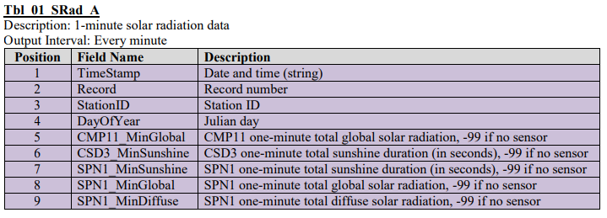
Files of the form:
xxxxxxxxxxxx_60_SRad_A_000X_M.CR3
Are text files containing hourly solar radiation data.


